Respiration

Aerobic respiration consumes oxygen and generates carbon dioxide. In order to measure respiration rates, it is necessary to focus upon one part of this equation. In today’s lab will be measuring oxygen consumption. To do this, you will have to eliminate carbon dioxide production. This will be accomplished by using baralyme to absorb the carbon dioxide.

Observe the apparatus set up as a demonstration. This device is called a manometer. The test tubes are the reaction chambers. Each test tube will contain either a living organism or a control.

Experiment
- Label three test tubes (‘C’ for Crickets, ‘BS’ for Bean Sprouts, and ‘GB’ for Glass Beads.)
- Place a cotton ball in each tube. Weigh each tube with cotton ball, and write down the weight
- Add 4-6 crickets to the ‘C’ tube and reweigh it. Write the new weight down.
- Repeat this process with the tubes that will hold bean sprouts and glass beads.
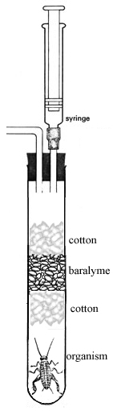
- find the weights of the crickets, bean sprouts and glass beads.
Table 1 a
Weight | ‘C’ Crickets | ‘BS’ Bean Sprouts | ‘GB’ Glass Beads
Tube + cotton ball |  | X | X
Tube, cotton, specimen |  | X | X
Specimen mass

Now write down your masses and those of two other groups that you will share data with.
Table 1 b
Temperature | ‘C’ Crickets | ‘BS’ Bean Sprouts | ‘GB’ Glass Beads
Weights for Hot
Weights for oom temp
Weights for Cold

- Push the cotton ball into the test tube until it is about 4” from the bottom of the tube. Add 1” of baralyme to each tube, then add another cotton ball. Place a stopper with a hose in the mouth of each test tube. Connect the other end of the hose to the manometer tubes AFTER USING SOAP TO LUBRICATE THE MANOMETER TUBE. Be careful not to break the glass rod.

- Place a piece of graph paper under the manometer tubes and tape it in place.
- Wait five minutes before continuing!!! This waiting period is needed to allow the air in the tubes to contract or expand because of the changing temperature of the air in the tubes.
- Insert a small amount of green dye into each of the manometer tubes, putting it in the end away from the test tubes. Be sure that you only have one drop of green dye per manometer tube, and that it takes up less than 1” of space in the tube. You can adjust the position of the dye within the tube by using the syringe (SEE SECOND ILLUSTRATION)
- Track the movement of the dye, taking measurements each 5 minutes. You should record the TOTAL movement of the dye (i.e. the distance from the starting point.) Record this information in table 2.

You will need to record the data from at least one warm, one cold, and one room temperature group

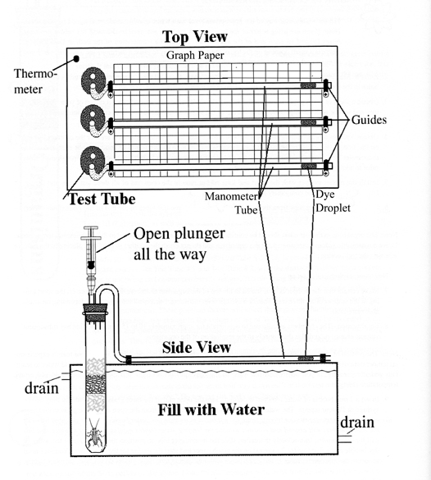

Table 2

 | 5 min | 10 min | 15 min | 20 min | 25 min | 30 min
HOT
Cricket movement
Bead movment
Cricket minus bead
Sprout movement
Bead movement
Sprout minus bead
COLD
Cricket movement
Bead movment
Cricket minus bead
Sprout movement
Bead movement
Sprout minus bead
ROOM TEMP
Cricket movement
Bead movment
Cricket minus bead
Sprout movement
Bead movement
Sprout minus bead

The glass beads were included in your test to serve as a control. We know that they are non-living, so they obviously are non-respiring. By subtracting any movement of the green dye in the tube for the glass beads, we can remove the effect of air expansion/contraction due to heating or cooling. We can also adjust for any mistakes caused by bumping the manometer.

We will now convert the data from the first table to show how much oxygen was used by each gram of living organism. To do this, take your “cricket minus bead” and “sprout minus bead” data for each temperature and enter them on Table 3. Then divide each of these by the mass of the organisms inside that tube.

Table 3

HOT | 5 min | 10 min | 15 min | 20 min | 25 min | 30 min
Cricket minus bead
Cricket mass
Respiration/gram
sprout minus bead
sprout mass
Respiration/gram
COLD | 5 min | 10 min | 15 min | 20 min | 25 min | 30 min
Cricket minus bead
Cricket mass
Respiration/gram
sprout minus bead
sprout mass
Respiration/gram
Room Temp | 5 min | 10 min | 15 min | 20 min | 25 min | 30 min
Cricket minus bead
Cricket mass
Respiration/gram
sprout minus bead
sprout mass
Respiration/gram

Now graph the data from Table 3. Make a line graph, with six different lines. You should put your time on the X axis and your adjusted data (respiration/gram) on the Y axis.

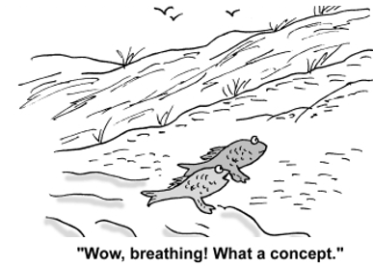



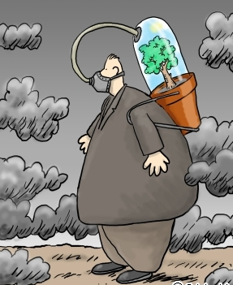

Remember where your oxygen comes from!!!

