Enzyme Lab

Explanation:
Enzymes, substrates, active sites, inhibitors
Equipment and how to use it
Graphing

Testing
Effect of concentration on enzyme activity
Effect of temperature on enzyme activity
Effect of pH on enzyme activity

Questions About the experiments

Data Sheet for Enzyme Lab

Enzymes and concentration
Conc. | Mixing | H₂O₂ | RPM | Time for 15 ml O₂ | Total amount/time
100% | 10 ml enzyme
70% | 7 ml enzyme + 3 ml ringers
50% | 5 ml enzyme + 5 ml ringers
30% | 3 ml enzyme + 7 ml ringers

Graph your data
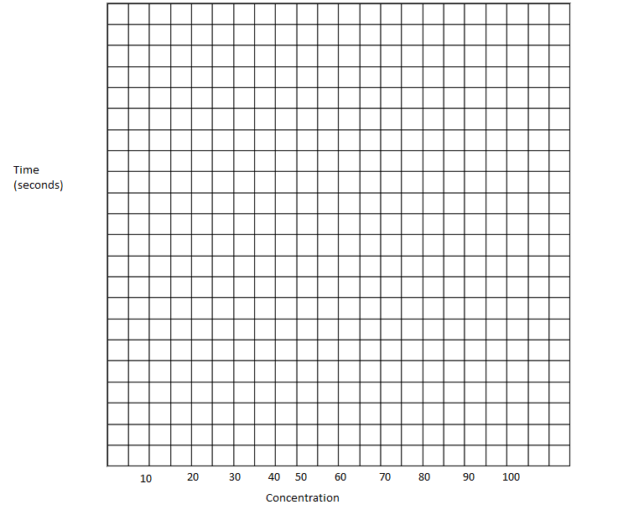

Enzyme temp
 | °C | H₂O₂ | RPM | Time for 15 ml O₂ | Total amount/time
Room temp
Warm
hot

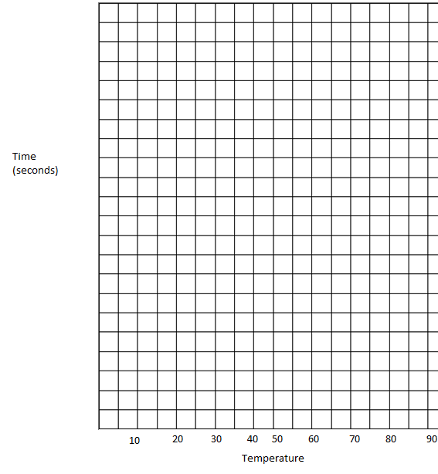

Enzyme at pH
Test | pH | H₂O₂ | RPM | Time for 15 ml O₂ | Total amount/time
1
2
3
4
5

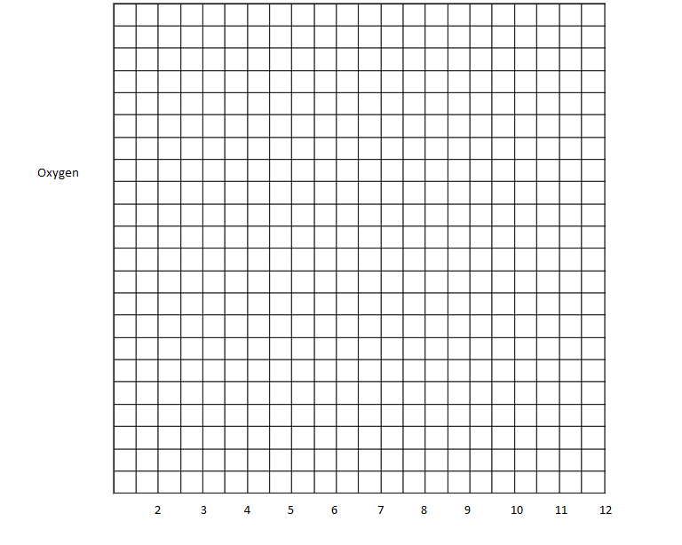

Summary Questions

What is an enzyme

What does it do

How does it work

What was the most active concentration

What was the least active concentration

What was the most active temperature

What was the least active temperature? Why?

What was the most active pH range?

What was the least active concentration?

When do enzymes work best?

