Diffusion And Osmosis

Overview
Diffusion of three dyes in a solid
Osmosis and sugar solutions
Osmosis and living plant cells

Osmosis and sugar solutions
you will fill three bags with different sugar solutions and measure their weight to determine how much water moves in or out of each bag

- Open dialysis tubing. To do this, rug the tubing under a stream of water to loosen the sides.
- Knot one end to make a bag.
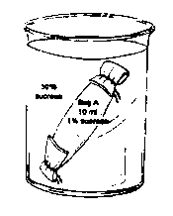
- Fill with 10 ml of the appropriate sugar solution
- Fasten the other end by tying or using a twist tie
- Dry the bag on paper towels
- Weigh the bag
- Record the weight of the bag
- Place in a beaker of water
- Write the original weight on the beaker
- After 30 minutes, remove the bag and dry it
- Record the new weight
- Make a bar graph of the change weight, putting syrup
concentration on the X axis and weight change on the Y axis

Bag Contents | Original Weight | After 30 minutes | Weight Change
10 ml water
5 ml water & 5 ml syrup
10 ml syrup

Did the bags gain or loose weight? What does this tell us about the movement of water?

Which bag had the biggest change? Why?

0% 50% 100%
Diffusion of three dyes in a solid
- Take solid particles of three dyes (e.g. acetocarmine, Methylene Blue, Potassium permanganate) and place them on an agar plate
- Label the agar plate to identify each type of dye
- Record the size of each dye spot
- Record the new size of each dye spot at 10 minute intervals, and the total change (difference from original size)
- Make a line graph to show the spread of each dye. You should have three lines (one for each dye.) Put the amount of change on the Y axis and time on the X axis

 | Width | Total | Width | Total | Width | Total | Width | Total | Width | Total
Dye | 0 min | change | 10 min | change | 20 min | change | 30 min | change | 40 min | change
Acetocarmine
Methylene Blue
KMnO4

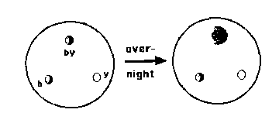

Which dye diffuses the fastest?

Give two possible reasons why one dye can diffuse faster than another dye?

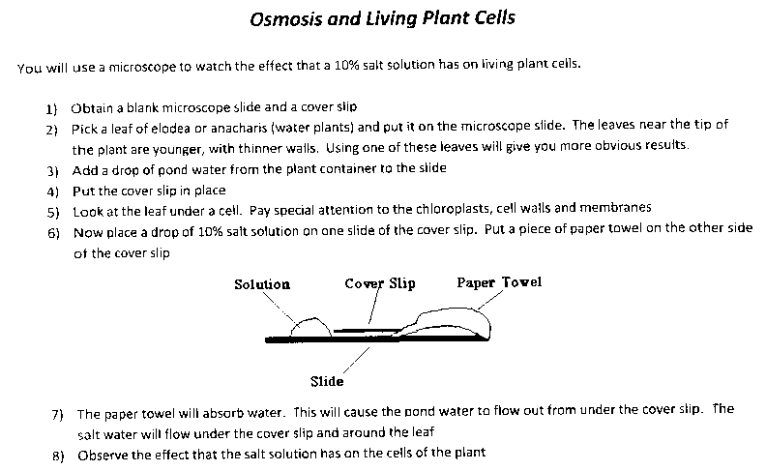
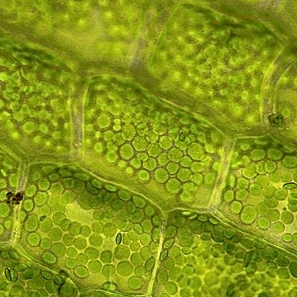
A B
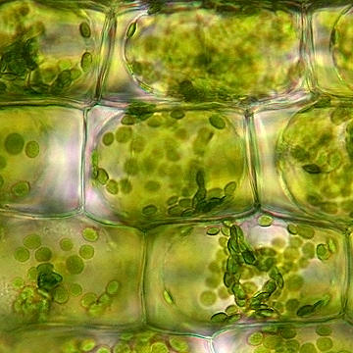

Which picture (A or B) is of elodea in salt water

What has happened to the cells exposed to salt water

Find definitions for these terms. (Yes, you may use the internet)
Crenation: Plasmolysis:

