This is the
ultra-exciting,
super fabulous,
wonderfully entertaining*
DNA Plastic Puzzle Lab!

Today we are going to play with little bits of plastic to demonstrate what DNA and RNA are made of, and how the processes of transcription and translation work. It might help to recall the little cartoon we watched that mentioned DNA, RNA and viruses and to review a few basic terms.

Transcription: Reading DNA to make an mRNA copy
Translation: Reading mRNA and using instructions to make a protein

Item | Made of | Function | Analogy
Nucleus | Membranes surrounding DNA | Holds DNA. Where DNA→RNA transcription happens | Castle
DNA | Nucleic Acids (deoxyribose) | Original source of information on how to make proteins | Recipe book that never leaves castle
RNA Polymerase | Amino Acids | Enzyme that makes RNA | scribe
pre-mRNA | RNA | Will become mRNA | Rough draft of recipe
“Editing enzymes” | protein | pre-mRNA ➔ mRNA | Editor: changes rough draft
mRNA | mRNA is one form of RNA (a nucleic acid with ribose) | Message for ribosome that says how to make a protein | Copy of recipe that needs to go to chef
Nuclear Pore | Hole through a membrane protein | How mRNA leaves the nucleus | Window of castle
Ribosome | rRNA (nucleic acid, ribose) | Use instructions from mRNA to make a protein | chef
tRNA | tRNA is one form of RNA (a nucleic acid with ribose) | Brings amino acids to ribosome that is reading mRNA strand | Helper to chef (“Iron Chef” edition of video)

In today’s lab you will use plastic puzzle pieces to do transcription and translation. The basic concepts we want you to learn are:
Parts of a nucleotide
Differences between DNA and RNA (KNOW THREE DIFFERENCES!!!!)
Templates and complementary Strands
Chargraff’s rules for pairs of nitrogenous bases
The difference in Transcription and Translation
Codons and amino acids

* - OK, not really, but it is a lot more fun than listening to more lecture
Key to Puzzle Pieces

s | Piece | Shape
Sugars
Deoxyribose | A | 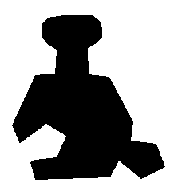
Ribose | B | 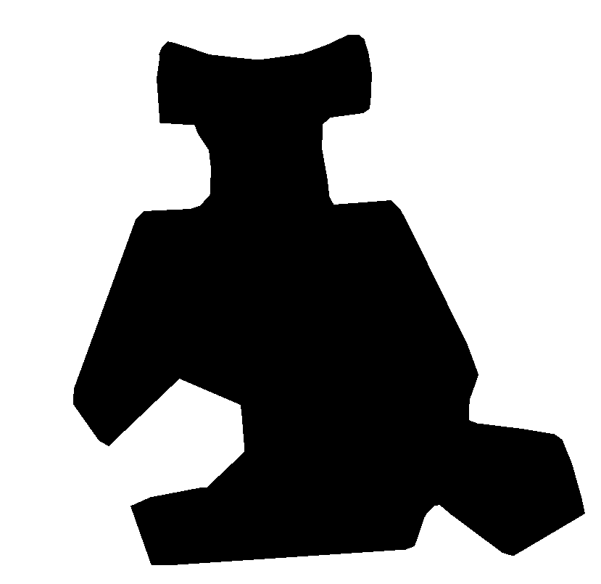
Phosphate | C | 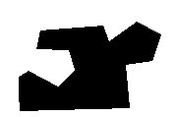
Bases
Adenine | J | 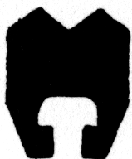
Guanine | F | 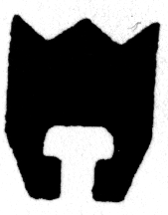
Cytosine | G | 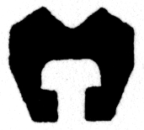
Thymine | E | 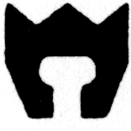
Uracil | D | 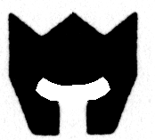

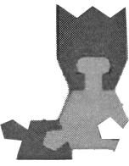
Instructions

Each nucleotide has a sugar, phosphate and a nitrogenous base. (RNA uses Ribose for the sugar, and DNA uses De-oxyribose for the sugar.) Use the pieces described on the last page to build a nucleotide. Now that you’ve made a nucleotide, let’s talk learn about the types of nucleotides that can be made.

- Figuring out which Bases fit each sugar

Most bases can combine with either Ribose or De-Oxyribose, but this is not true for all bases. Try each base with both sugars. Record your results in the table below. Use a “yes” if the base and sugar combine, and a “no” if the base and sugar do not combine.

Base | Ribose | De-oxyribose
Adenine
Cytosine
Guanine
Thymine
Uracil

2. Building a DNA strand

Build a DNA chain of AT LEAST SIX nucleotides. The backbone of the chain is made of _____________ and ________________ 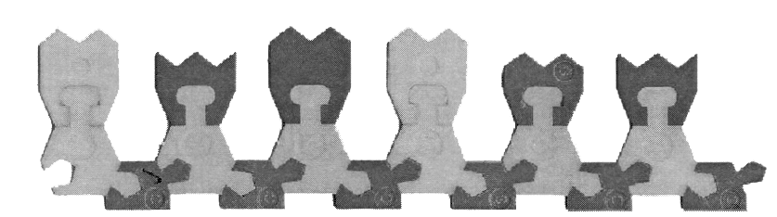

Write down the six bases used in your DNA strand

1 | 2 | 3 | 4 | 5 | 6

3. Template Strands and Complimentary Strands

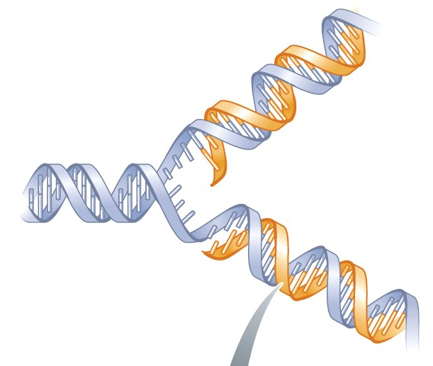
A template is a strand that you are reading when you make a new strand. (the new strand is called a “complimentary” strand.) During interphase, when we are doubling DNA in preparation for cell division, double stranded DNA is unwound and the strands are separated. Each strand from the original DNA molecule is used as a template strand, and a new compliment strand is created. The result is two DNA molecules, each one with one old strand and one new strand.

Use your DNA polymer from question two as a template. Build a complementary strand of DNA. Complete the chart below, writing in the base used on the second strand

 | Template DNA Strand | Compliment DNA strand
1
2
3
4
5
6
7 | Adenine
8 | Cytosine
9 | Guanine
10 | Thymine
11 | Adenine
12 | Adenine
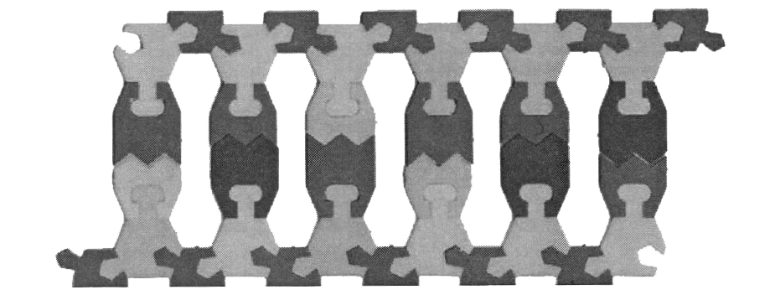

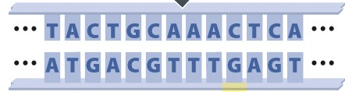

4. Transcription

In transcription, we read a DNA strand and build a complimentary RNA strand. That strand will be “edited” (i.e. have the introns removed) into messenger RNA (mRNA) that will later be read by a ribosome. For the first six rows, use one of your DNA strands as a template and write the complimentary RNA base. For the next six rows, read the RNA base and write down what would have been on the DNA template.

 | DNA Strand | Matching RNA Strand
1
2
3
4
5
6
7 |  | Adenine
8 |  | Cytosine
9 |  | Guanine
10 |  | Uracil
11 |  | Adenine
12 |  | Adenine

Give 2 ways that RNA ALWAYS differs from DNA. Give one way it USUALLY differs from DNA.
___________________________________________________________________________________________________________________________________________________________________________________________________________________________________________________________________________
5. Translation reading RNA and building a protein. Write the RNA strand from the last exercise into the table below. Use this chart to list what amino acids would be in the protein it codes for.
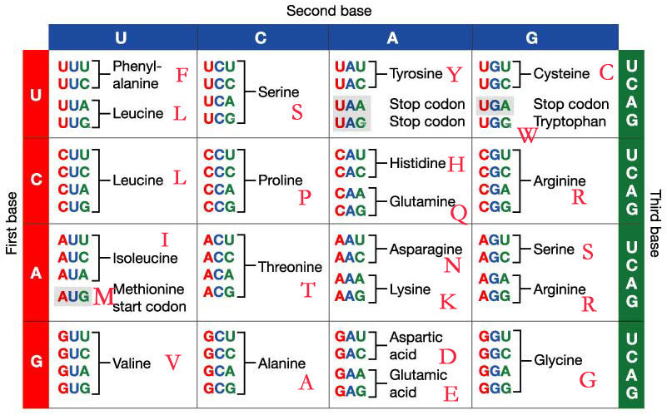

 | mRNA Strand | Amino Acid
1
2
3
4
5
6
7 | Adenine
8 | Cytosine
9 | Guanine
10 | Uracil
11 | Adenine
12 | Adenine

6. Explain what a Codon is. What effect would an insertion or deletion have on the sequences of amino acids in a protein?

________________________________________________________________________________________________________________________________________________________________________________________________________________________________________________________________________________________________________________________________________________________________________

