Biological Molecules

Purpose:
Test for organic compounds (reducing sugars, starches, proteins, fats, vitamin C) and interpret the results
Learn which reagents are used to test for each of these substances
To understand the purpose of a control in a scientific experiment

Materials
Reagents: Benedict’s (reducing sugars), iodine (starches), Biuret’s (proteins) Sudan stain (fats)
Items to test: various food items which may include things like water, glucose, starch, onion juice, potato juice, onion slices, potato slices, albumen, broth, cream, coconut, vegetable oil, avocado, banana slices, and stuff for pH test (soda, orange juice, coffee, laundry detergent)
Filter paper disks
Boiling water bath
Litmus paper for pH test

Carbohydrate Tests
Using Benedict’s to test for reducing sugars
The basic subunits of carbohydrates are simple sugars or monosaccharides (“one sugar”). These sugars are often linked together to form chains called polysaccharides (“many sugars”). Examples of carbohydrates include glucose (a monosaccharide), maltose (a disaccharide made by hooking two glucoses together), and starch (a polysaccharide made of glucoses.)

Benedict’s Test for Reducing Sugars
The Benedict’s test detects the presence of carbohydrates reducing sugars (e.g. glucose, galactose, maltose, lactose.) A positive test for one of these will change the reagent’s color. The amount of color change depends on the concentration of the reducing sugar. (Green = low concentration, brick red = high concentration.) Any color change indicates a positive result. If the reagent stays blue, the test is negative (e.g. starch or other non-reducing sugar).

- Start a boiling water bath for this test. Use a large beaker (400 ml or larger) that is filled halfway.
- Number 6 clean test tubes, and place 1 ml of the following solutions in the corresponding labeled tube: 1 = water, 2 = glucose, 3 = sucrose, 4 = starch, 5 = onion juice, 6 = potato juice
- Add 2 ml of benedict’s reagent to each tube. Put the tubes into the boiling water bath for 2-3 minutes. You may boil all the tubes together.
- Record any color chage in Table 1 and your conclusion regarding the presence or absence of reducing sugars in each sample.

Table 1. Results for Benedict’s Test
Test Tube | Color before boiling | Color after boiling | + or - | Conclusion
1. Water

2. Glucose

3. Sucrose

4. Starch

5. Onion slice

6. Potato Slice

Iodine Test for Starches
Starches, another carbohydrate, can be detected by iodine. If plant starches are present, iodine (IKI) will change from a dark yellow-brown to a dark blue-black. (This is a positive test.) If the solution stays yellow, there is no starch, or too little to detect (negative test)
You will test fresh samples of six substances for the presence of starch. You will need a ceramic spot plate with two drops of each of the first four solutions (from the stock bottles) in separate wells. In the fifth and sixth wells, place a small slice of onion and potato, respectively. Add one drop of the IKI solution to each end well and, in Table 2, note any color changes and your conclusions regarding the presence or absence of starch in that sample.

Table 2. Results for Iodine Test
Spot | Color before iodine | Color after iodine | + or - | Conclusion
1. Water

2. Glucose

3. Sucrose

4. Starch

5. Onion slice

6. Potato Slice

Based on your results from the Benedicts and Iodine test (Tables 1 and 2), you can conclude that potatoes store carbohydrate as:

And onions store carbohydrate primarily as:

Biuret’s Test for Protein

Proteins (polypeptides) are long linear chains of amino acids. Each polypeptide chain fold spontaneously into a characteristic three-dimensional shape that is essential to its normal function. Some kinds of protein are important structurally to cells providing a dynamic internal scaffolding for cell shape. Others are enzymes that make possible the complex array of specific chemical reactions essential to life.

Biuret’s reagent detects the presence of proteins and short peptides. As for the other tests, the color of the solution indicates whether proteins are present (positive result) or abscent (negative result). For the Biurete test, a positive result for protein is violet, and blue is negative.

- Number 4 clean test tubes with a wax pencil.
- Place 1 ml of the following solutions into the tubes: 1 = water, 2 = egg albumin, 3 = starch, and 4 = chicken broth.
- Add 3 drops of biuret reagent to each tube
- Record any change in color and your conclusions in Table 3.

Table 3. Results for Biuret’s Test

Table 3 Results for Biuret Test
Test Tube | Color before biuret’s | Color after biuret’s | + or – Result | Conclusion
1. Water

2. Albumin

3. Starch

4. Broth

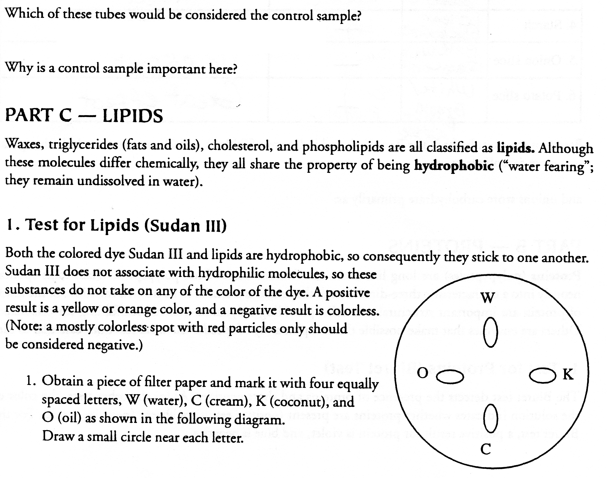

- Using the proper pipet, add a small drop from each tube to the appropriate circled spot on the filter paper. Be sure to return the pipet to its proper solution.
- Let the filter paper druy completely. Use a blow dryer if necessary.
- Soak the paper for 3 minutes in the culture dish of Sudan III solution. (One filter paper disk at a time.)
- Use forceps to remove the paper from the dye. Rinse the paper for 1 minute in a culture dish of freshly distilled water.
- Record the color of the spots and your conclusion in Table 4

Table 4. Results for Sudan Test

Spot | color before sudan stain | Color after sudan stain | + or – Result | Conclusion
W. Water

C. Cream

A. Avocado

O. Oil



Test | Molecules Tested For | Color of Positive | Color of Negative
Benedict’s

Iodine

Biuret

Sudan

