PLANT ADAPTATIONS

Plants have adapted to live in most habitats on the planer; so, it would take years to cover all the many ways that plants have adapted to their environments. In this lab we will look at several environmental conditions and the adaptations plants have used to overcome these conditions.

LIGHT

Availability of light is one challenge that all photosynthetic organisms face. Without light there can be no photosynthesis. Some adaptations for low light are as simple as plants in the understory of the forest having larger leaves because they get less sunlight: the greater surface area they have, the more chance they have of harvesting the little bit of sunlight that reaches the forest floor. The same adaptation can be seen in trees that are shaded, the leaves in the shade (shade leaves) become much larger than the leaves in the sun.
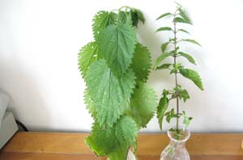
http://www.field-studies-council.org/publications/resources/ks3/images/Nett-wilt10.13_large.jpg

Observe the sun and shade leaves.

Vining. Another strategy for acquiring sunlight is to adopt a vining form. Many plants have become vines, and some of those eventually become large woody vines called lianas. In the tropics these lianas may have to grow very long to reach the sunlight in the forest canopy.

Vining takes several forms. Some plants simply bend around other plants, wrapping them as they continue to grow. Others produce specialized tendrils, which be modified leaves or modified stems.
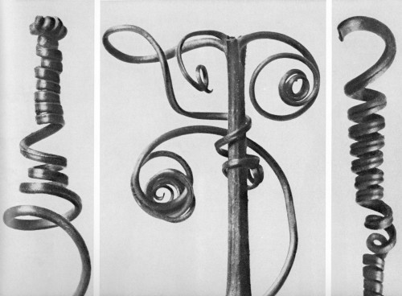
http://img.visualizeus.com/thumbs/07/11/03/art,bw,photography,plant,tendrils-4bc1455c29832a068a47dd4a6751e3a4_h.jpg

Observe the vine demonstration.

Can you tell whether the tendrils are modified leaves or modified stems?

Some plants obtain sunlight by living on the branches of other plants (epiphytes). A common Floridian example of this is Spanish moss (Tillansdia usneoides). Spanish moss grows on the branches of other plants. The tree it is on is unaffected, but the Spanish moss gets much more sunlight by being above the ground. This is a commensalistic relationship. Many orchids and bromeliads live as epiphytes.

Observe the epiphytes on display.

WATER

Like all living organisms, plants require water. Unlike animals, plants are unable to relocate when water becomes scarce or too abundant. Plants have developed strategies to deal with too much and too little water.

A common mutation is that plants in areas of high rainfall have leaves that end in a longer point, often called a drip tip. The drip tip allows water to drain off of the leaf more quickly.
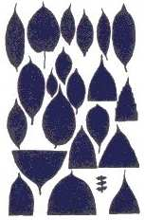
http://www.lankalibrary.com/wlife/parks/Figure10.jpg

Observe the leaves with drip tips.

Another common problem is lack of water. Plants in arid regions have had to make adaptations to accommodate an infrequent supply of water. Several common themes can be seen. One adaptation that can’t be as easily observed is Crassulacean Acid Metabilsm (CAM), a for of photosynthesis that allow stomates to be closed during the day. Stomates are the point of gas exchange in plants. Oxygen exits the stomates, and Carbon Dioxide, the source of the carbon used to build sugars, enters the plant through the stomates. However, water vapor exits plants through transpiration whenever stomates are open. CAM allows plants to only open their stomates at night, resulting in less water loss.

Reduction of surface area. The greater the surface area of a plant, the more water is can lose. Thus, in times when water is scarce, big leaves are a liability. We can observe this among deciduous plants, plants that drop their leaves. We may picture this as a response to winter, but in large part, it is a response to the lack of available water in winter. When water is frozen, it is unavailable to biological systems; so leaves become a liability. In Florida we see that oak trees also drop their leaves during the dry season. Similar patterns can be seen in much of the world; when it is dry, plants drop their leaves.

In areas where water is unavailable most of the time, plants have made more permanent adaptations. Cacti have mostly been reduced to photosynthetic stems: the leaves have become the protective spines. Other groups of plants have also dropped leaves in favor of photosynthetic stems. These plants also store water in the stems, making them succulent plants.

Other cacti have done away with leaves but don’t have a lot of spines.

Some plants from arid regions have developed thick fleshy leaves, which is another form of succulence. One group from southern Africa (the Aizoaceae) has many species which have fleshy leaves and large showy flowers. When not in flower these plants blend in with the gravel surrounding them.

Note that some of these are “window plants.” The top portion of their leaves is transparent, allowing sunlight to penetrate deeper into the leaf where more cells can photosynthesize.

Many other desert plants have fleshy leaves that they arrange in a rosette formation. These rosettes give them an overall lower exposed surface area, yet allow them to store large amounts of water. Because much of the leaf tissue is away from sunlight, many of these rosette plants also develop leaf windows. Other plants from arid regions produce smaller leaves that are thickened.

Some desert plants are covered in hairs. The hairs shade the plant and reduce water loss.

Observe the desert plant examples.
NUTRIENTS

Plants need water and carbon dioxide for photosynthesis, but they also need many other nutrients to maintain healthy cells and to grow. These nutrients are not equally available in the world; so plants have made adaptations to acquire nutrients.

One nutrient that is often in short supply in acidic habitats is Nitrogen; however insects are a readily available source of Nitrogen. (Remember that nitrogen is an essential component of all amino acids. It is also part of chitin, a modified glucose polymer, that makes up the exoskeleton of insects). Thus, plants that could capture and digest insects would have a good source of Nitrogen. The insect eating plants “Carnivorous Plants) can be found in poor soils throughout the world.

Observe the Carnivorous Plants.

Several different methods of capturing insects have developed. Some systems are passive, while others are active.

Venus Fly Trap Dionaea muscipula (DO NOT TRIGGER THE TRAPS!!!!)
Venus Fly Traps are only found in the wild in North and South Carolina. They have active traps (made from modified leaves) that rapidly close after an insect touches several trigger hairs on the leaf surface. The cells along the midvein of the leaf rapidly swell, but the other leaf cells don’t enlarge. The effect of this is that the edges of the leaf rapidly grow toward each other. Each leaf can only function a few times before it is no longer capable of this rapid growth. Many people kill their venus fly traps by overstimulating the leaves
. 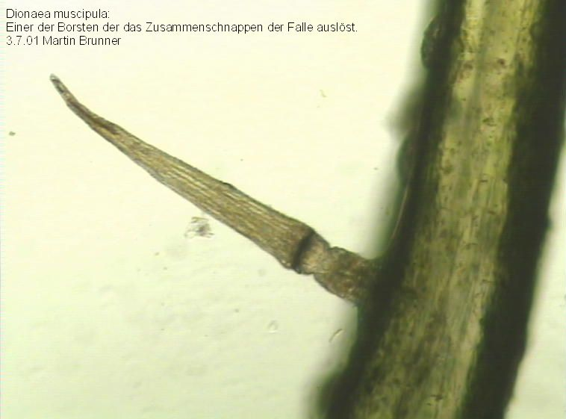 Venus Fly Trap trigger hair http://upload.wikimedia.org/wikipedia/commons/d/dc/Dionaea-muscipula-Ausloeseborste-Mikroskopaufnahme.jpg
Sundews. Drosera. The genus Drosera is a huge genus of carnivorous plants that have a sticky sap on their leaves. The glue is exuded from hairs found on the leaf surface. The glue also contains the digestive enzymes; so an insect is held in place by the glue while simultaneously being digested from the outside. Florida has several species of Sundews, including a species in the Panhandle that can reach 1 foot in height. The species in Polk County is much smaller.
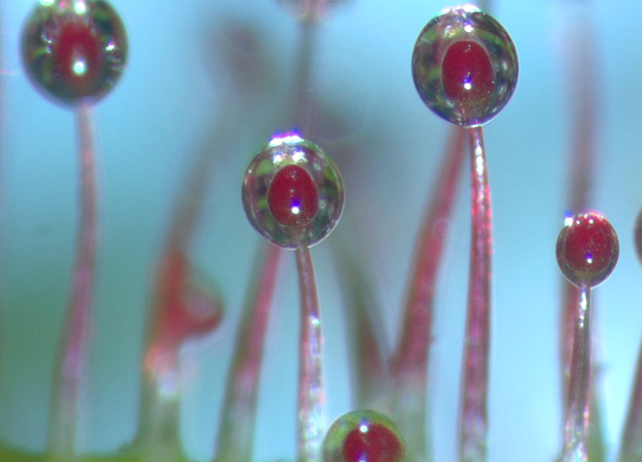
http://www.olympusbioscapes.com/gallery/2004/images/2004-hm-11-large.jpg

Sundews can be passive or active. Many species don’t react to the presence of a prey insect, but others will start folding the leaf around a trapped insect so that more sticky hairs touch the surface of the insect, helping ensure that it remains trapped and speeding up the digestion process.

Butterwort Pinguicula Pinguiculas are strictly passive carnivores. Their leaf surfaces are sticky and very small insects stick to them. The plant’s enzymes then help digest the trapped insects.

Tropical Pitcher Plants Nepenthes There an many species of Nepenthes and the pitchers of several can get large enough to trap small mammals. Most, however, trap insects. The pitcher is the modified tip of a leaf. Each pitcher has fluid in its base that helps to trap and drown prey and also helps digest them. The inner surface of the pitcher is very slick and contains many downward pointing hairs. Thus, when a trapped insects tries to climb out, it slips back down into the fluid, eventually drowning.

PROTECTION

Plants are often consumed by other living organisms, so they have developed many strategies to reduce the level of predation. Some plants produce lots of nasty chemicals that make them taste bad or that are poisonous. A great example of this is tobacco. Tobacco leaves are loaded with noxious chemicals meant to keep chewing insects away. An easy insecticide is to boil the tobacco from a cigarette, strain out the leaves, put it in a spray bottle and spray it on the insect problem. Depending on the dosage, it can immediately kill many insects; others will just go away to avoid the tobacco squeezin’s.

Many plants produce an astringent chemical called tannic acid. Tannic acid gives coffee, tea and the Okeefenokee Swamp their characteristic brown color.

Other plants develop physical protections like the spines of cacti and other desert plants or the thorns of roses. Some plant species even load these physical protections with a stinging chemical, like the stinging hairs of nettles. These hairs are filled with several painful chemicals including formic acid.

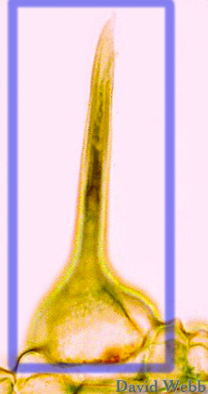 http://www.botany.hawaii.edu/faculty/Webb/BishopWeb/UrticaStingHairLab.jpg
Nettle Hair filled with stinging chemicals

Some plants have developed partnerships with ants to help defend themselves. These plants are called myrmecophytes “ant plants.” Some myrmecophytes just provide the ants with a good place to live. Others go beyond that, providing not only a home, but a food source. If any insect comes along and decides that the ant plant looks tasty, the ants rush out and attack it. They have also been known to trim away vines or leaves that touch their host plants.

Myrmecophila This orchid produces large hollow pseudobulbs. As it’s Latin name Myrmecophila (“ant lover”) suggests, ants often chew into these pseudobulbs and establish colonies inside.

Lecanopteris pumila This fern produces large swollen rhizomes. Ants burrow into these hollow rhizomes and establish colonies.

Acacia cornigera Bullhorn Acacia This plant takes the relationship one step further. It produces swollen spines that provide a home for ants, but the leaves also produce protein and lipid rich Beltian Bodies on the lips of its leaflets.

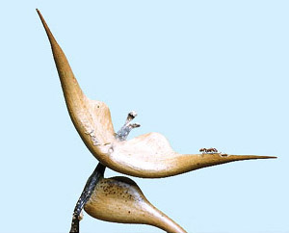
http://insectzoo.msstate.edu/Images/rh46ab.JPG

