Mitosis

- Overview of process and stages
- Learn to identify cells undergoing Mitosis
- Calculate percentages of cells in each stage
- Use percentages to find approximate time spent in each stage.

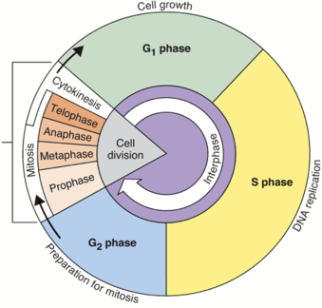

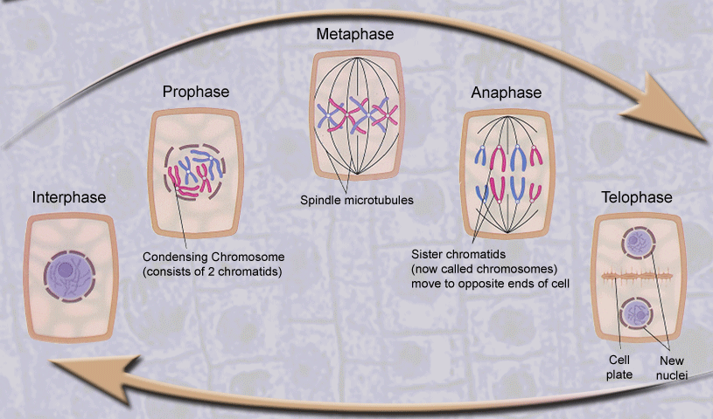
Identify the stages of mitosis

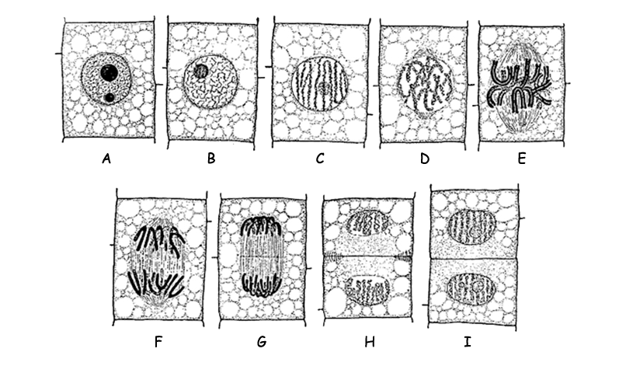

Look at the photograph below. Find, circle, and label at least one prophase, metaphase, anaphase and telophase

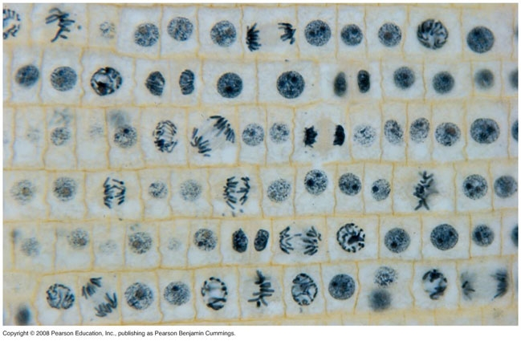

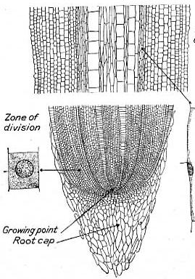
Now use a microscope and a hand tally to examine a slide of onion root tip. (The slide may be labeled “Allium Root Tip”)
You will look in the zone of division (the area behind the root cap)
for an area of the slide that shows all stages of mitosis.

After you find an area with all stages, count the number of cells
you see in each stage of division. DO NOT MOVE THE
MICROSCOPE STAGE DURING THIS PROCESS. IF YOU MOVE IT
YOU WILL NEED TO START OVER.

Stage | Amount Seen
Prophase
Metaphase
Anaphase
telophase
Sum

Now estimate the number of cells in the field of view. Count the rows and columns:

___________(# of rows) x ___________(# of columns) = ____________(estimated total)
Math for plant cells

Find the percentage of cells in each stage of mitosis

Prophase: ( ________amount seen / __________estimated total) X 100 = _____________percent

Metaphase: ( ________amount seen / __________estimated total) X 100 = _____________percent

Anaphase: ( ________amount seen / __________estimated total) X 100 = _____________percent

Telophase: ( ________amount seen / __________estimated total) X 100 = _____________percent

Find the percentage of cells in interphase
Interphase: (__________estimated total - ___________SUM) = _____________estimated interphase cells

(_____________estimated interphase cells / _________estimated total) X 100 = _____________percent

Counting Animal Cells

Now use a microscope and a hand tally to examine a slide of whitefish embryo. (The slide may be labeled “whitefish blastula” or “whitefish mitosis”) Look for an area of the slide that shows all stages of mitosis.

After you find an area with all stages, count the number of cells you see in each stage of division. DO NOT MOVE THE
MICROSCOPE STAGE DURING THIS PROCESS. IF YOU MOVE IT YOU WILL NEED TO START OVER.

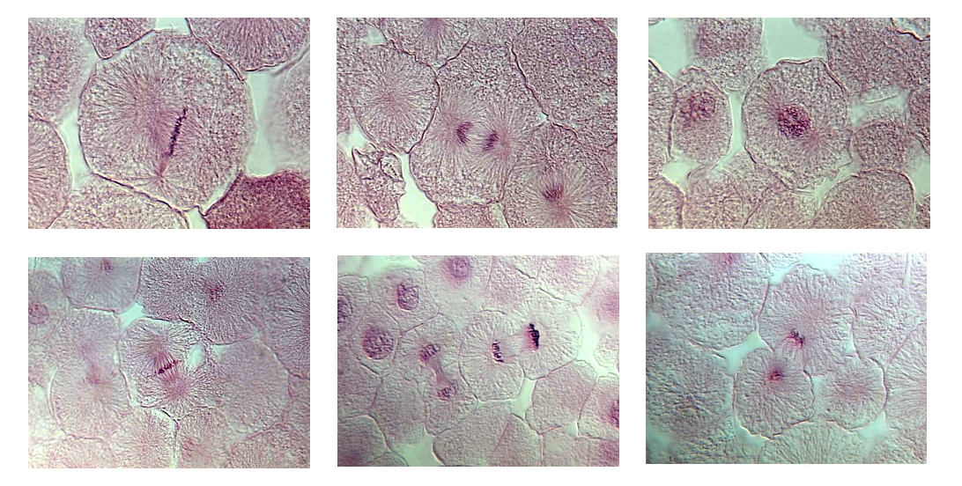

Stage | Amount Seen
Prophase
Metaphase
Anaphase
telophase
Sum

Now estimate the number of cells in the field of view. Count the rows and columns:

___________(# of rows) x ___________(# of columns) = ____________(estimated total)

Math for animal cells

Find the percentage of cells in each stage of mitosis

Prophase: ( ________amount seen / __________estimated total) X 100 = _____________percent

Metaphase: ( ________amount seen / __________estimated total) X 100 = _____________percent

Anaphase: ( ________amount seen / __________estimated total) X 100 = _____________percent

Telophase: ( ________amount seen / __________estimated total) X 100 = _____________percent

Find the percentage of cells in interphase
Interphase: (__________estimated total - ___________SUM) = _____________estimated interphase cells

(_____________estimated interphase cells / _________estimated total) X 100 = _____________percent

What percentage of time does an animal cell spend in interphase

What percentage of time does a plant cell spend in interphase

